REQUEST FOR THE RECOGNITION OF FOREIGN PROFESSIONAL QUALIFICATIONS

for the purpose of exercising the right of establishment in the Republic of Croatia

Date of receipt: |  | Number and date of entry:
CLASS:
REG.NO.: |  | CLASS:
 |  | REG.NO.:
Administrative fee: |  | Date of decision:
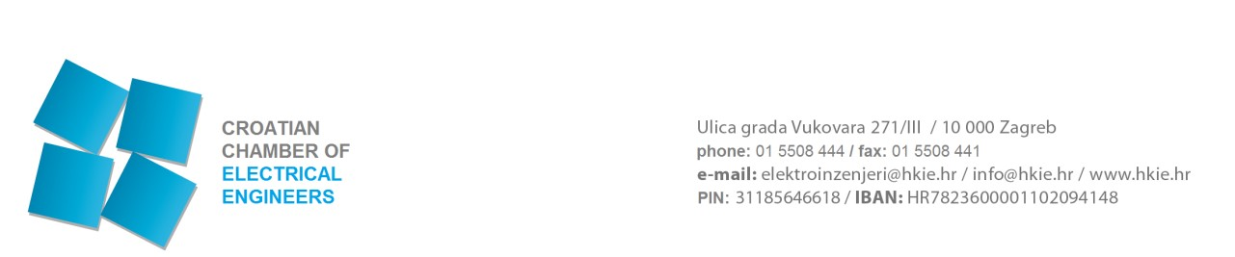

1. PERSONAL DATA
NAME: SURNAME:
Gender: Passport or personal ID card number:
Date of birth: Place of birth:
Country of birth: CITIZENSHIP:
PERMANENT RESIDENCE (required) Street and house number:
Postal code: City: Country:
PERSONAL CONTACT DETAILS (required)
Phone: Mobile phone:
E-mail:
CONTACT DETAILS IN THE REPUBLIC OF CROATIA (optional) Street and house number:
Postal code: City: Country:
Phone: Mobile phone:
E-mail:

Is the profession that you perform regulated in the country of establishment? YES NO

2. REGULATED PROFESSION
Name of the regulated profession, which you perform in the country of the establishment:
design,

professional supervision of construction,

construction manager of the electrical engineering profession,

performance manager of the electrical engineering profession

Name of the regulated profession, for which you request recognition in the Republic of Croatia:

Are you qualified to perform the abovementioned regulated profession, that is, activity in your domicile EU Member
State (circle)? YES NO
Is formal education enabling you to perform the subject profession organized in the EU Member State in which you are domiciled (circle)? YES NO

3. EDUCATION AND TRAINING
Name of the educational institution (in native language):
Address of the educational institution:
Name of the completed study:
Acquired title:
Date of graduation: University degree number:
Place of graduation: Country of graduation:
POSTGRADUATE DEGREE:
Master’s degree-field: Year of acquisition:

Doctoral degree-field: Year of acquisition:
OTHER PROFESSIONAL QUALIFICATIONS (PROFESSIONAL EXAM):
Indicate additional qualifications and the field in which you are further qualified:

4. PROFESSIONAL EXPERIENCE
Professional experience in performing the respective regulated profession, that is, regulated professional activity (provide dates, work organisations, workplace and attach the relevant certificates) - certified translation:

5. CONTACT DETAILS IN THE COMPANY OF EMPLOYMENT (required)
Company name and form of organisation:
Address:
Postal code and city:
Company registration number:
Phone: Fax: Mobile phone:
E-mail:
Job title:
Date of commencement of employment:
Responsible person of the company:

6. POWER OF ATTORNEY:
By signing the request, I hereby authorise the person stated below to take over on my behalf the complete documentation issued by the Chamber on the basis of my request
Name and surname of the authorised person:
Telephone/GSM (with the area code):
E-mail:

PLEASE INFORM ME OF THE COURSE OF THE PROCEDURE BY:

Mail: ___________________________
Fax: ___________________________
E-mail: _________________________
Via the authorised person: ____________

I WILL TAKE OVER THE DECISION ON THE RECOGNITION OF FOREIGN QUALIFICATIONS
(please circle):

- At the Chamber
- By mail (please enter the correct address): _________________________________

BY DULY SIGNING THE SUBJECT REQUEST, I HEREBY DECLARE:

  - UNDER PENALTY OF PERJURY THAT THE ABOVE INFORMATION IS TRUE, AS WELL AS THE SUBMITTED DOCUMENTATION AND APPENDICES TO THIS REQUEST;
  - THAT I AM WORTHY OF PERFORMING ENGINEERING TASKS, THAT I AM MEDICALLY FIT AND LEGALLY CAPABLE, THAT I HAVE NOT BEEN CONVICTED OF A CRIME
AGAINST THE REPUBLIC CROATIA, FOR A CRIME AGAINST OFFICIAL DUTY OR FOR A CRIME COMMITTED OUT OF GREED THAT WOULD RENDER ME MORALLY UNWORTHY OF PRACTICING ENGINEERING TASKS ACCORDING TO THE CODE OF PROFESSIONAL ETHICS;
  - THAT I AGREE THAT MY PERSONAL DATA, PURSUANT TO THE PROVISIONS OF THE PERSONAL DATA PROTECTION ACT, MAY BE COLLECTED, PROCESSED AND STORED BY THE CROATIAN CHAMBER OF ELECTRICAL ENGINEERS;
  - THAT I SHALL APPLY THE REGULATIONS OF THE REPUBLIC OF CROATIA AND ACTS OF THE CHAMBER ADOPTED THEREUNDER DURING THE PERFORMANCE OF WORK IN THE REPUBLIC OF CROATIA;
  - THAT I AGREE THAT MY PERSONAL DATA FROM THE RECORDS OF THE CROATIAN CHAMBER OF ELECTRICAL ENGINEERS BE PUBLISHED;
  - THAT I USE CROATIAN LANGUAGE AND LATIN SCRIPT FOR THE PURPOSES OF THE PROFESSION IN THE REPUBLIC OF CROATIA, THAT IS, THAT I SHALL USE TRANSLATION SERVICES AT MY OWN RISK AND COST.

Place and date: ______________________ Signature:________________________

Terms used in this Request in masculine gender are neutral and refer both to male and female persons.
APPENDICES (required)

- Evidence of citizenship (copy of a valid identification document, personal ID card or passport),
- Copy of the university degree/certificate,
- Copy of the university degree/certificate supplement,
- Evidence of authorisation for the performance of a regulated electrical engineering profession in the domicile country (not older than 6 months),
- Evidence of personal professional competence (professional experience gained since the end of Graduate university study in electrical engineering, that is, a specialist graduate study in electrical engineering). It is demonstrated by a chronological list and description of professional activities, which the applicant performed primarily during work on professional design and supervision tasks during the performance of electrical works until the date of submitting the request. In the chronological list of professional activities the date of starting and completing the task is given, as well as the name of the task with the location, brief professional description of the task and the type of task (design or supervision). (copiescertified translations),
- Evidence of qualifications and professional experience during at least two years - in the event that the profession is not regulated in the domicile country or another Member State you come from (copies-certified translations),
- Evidence of three years of professional experience in the territory of the EEA Contracting States (in case of education acquired in third countries, which have been confirmed by the subject EEA Contracting State) (copies-certified translations),
- Certificate/Declaration of no criminal record (copies - translation) -not older than 6 months

